

**Authorized Learning Center (Code:- 1537)**

**College for Professional Studies**

**Opp. Maitidevi Temple, Kathmandu, Nepal**

**PASSENGER CLEARANCE SYSTEM FOR CUSTOMS**

By

**RAMESH SUKAMANI**

**Roll No: 1308007007**

A project report submitted in partial fulfillment of the requirements for

MSC IT, Second Semester

of Sikkim Manipal University, DDE INDIA

Sikkim-Manipal University

Directorate of Distance Education

Manipal, India.

**Date of Submission:-2014/06/22**

##### PASSENGER CLEARANCE SYSTEM FOR CUSTOMS

##### A PROJECT REPORT

***Under the guidance of***

**<<Supervisor>>>>............**

***Submitted by***

Ramesh Sukamani

*in partial fulfillment of the requirement for the award of the degree*

***Of***

**MSC IT, Second Semester**



2014 June 22

**College for Professional Studies**

**LC of Sikkim Manipal University (01537)**

**VIVA VOCE SHEET**

We have examined the viva-voce examination of the graduate research report presented by

**RAMESH SUKAMANI**

Entitled

**Passenger Clearance System for Customs**

and found the report to be original work of the student and written according to the prescribed format of the University. We recommend the report to be accepted as partial fulfillment of the requirements for the MSC IT, Second Semester

**Viva-Voce Committee**

1. Supervisor/Project Guide

1. Program Coordinator
2. Chief Program Coordinator
3. External Examiner

Date: June 2014



**BONAFIDE CERTIFICATE**

Certified that this project report titled **“Passenger Clearance System for Customs”** is the bonafide work of **“Ramesh Sukamani”** who carried out the project work under my supervision.

**CERTIFIED**

**………………………………..**

**<<Supervisor>>>>............**

**Project Supervisor**

Department of Computer Science

College for Professional Studies

LC of Sikkim Manipal University

LC Code: 01537



**Certificate from University Learning Centre**

This is to certify that **Ramesh Sukamani** of MSC IT has worked on the project as per the course curriculum of MSC IT, Second Semester. This project entitled “**Passenger Clearance system for customs**” is the original work of Ramesh Sukamani and was carried out under the supervision of **Mr. <<Supervisor>>>>............** as per the guidelines provided by the university. As per the student’s declaration this is certified that his project has not been presented anywhere as a part of any other academic work.

**………………………**

**P. Kejriwal**

**Founder**

**………………………**

**Er. Pankaj Jalan**

**Executive (Director)**

**………………………**

**Er. Prakash Kumar**

**Director (Academics)**



**Certificate from University Learning Centre**

This is to certify that **Ramesh Sukamani** of MSC IT has worked on the project as per the course curriculum of MSC IT, Second Semester. This project entitled “**Passenger Clearance System for customs**” is the original work of Mr. RAMESH SUKAMANI and was carried out under the supervision of **Mr. <<Supervisor>>>>............** as per the guidelines provided by the university. As per the student’s declaration this is certified that his project has not been presented anywhere as a part of any other academic work.

**………………………**

**Prof. Dr. Mahendra Singh**

**Chief Academic Advisor**

**………………………**

**Sachin Malla**

**Program Coordinator**

**………………………**

**Uday Kant Jha**

**Chief Coordinator**

**Recommendation Letter**

Date:-2014/06/20

To,

The Project Coordinator,

College For Professional Studies.

**Sub:- Recommendation for researching by Ramesh Sukamani.**

Respected Sir,

I am glad to inform you that student of College For Professional Studies RAMESH SUKAMANI had researched in our TIA CUSTOMS OFFICE, GAUCHAR, KATHMANDU and he has successfully completed his research in this TIA CUSTOMS OFFICE.

I regard him as a good person with intellectual skills.

Thank You

Customs

Name of Candidate: Ramesh Sukamani



**Student declaration**

I hereby declare that the project report entitled

**PASSENGER CLEARANCE SYSTEM FOR CUSTOMS**

Submitted in partial fulfillment of the requirements for the degree of

MSC IT, SECOND SEMESTER

To Sikkim-Manipal University, India, is my original work and not submitted for the award of any other degree, diploma, fellowship, or any other similar title or prizes.

Place: Kathmandu RAMESH SUKAMANI

Date: Reg. No: 1308007007

#### ACKNOWLEDGEMENT

I would like to extend my sincere thanks to my supervisor Mr. <<Supervisor>>>>............ for all his efforts in bringing this project to fruition. Without his guidance this project could never have been realized.

Further, I would like to extend my earnest gratitude to Chief Academic Advisor Pro. Doc. Mahendra Singh and Program Coordinator Mr. Udaya Kant Jha and Sachin Malla for providing me valuable support to complete this project. I would also like to extend my thanks to Mr. Laxman Subedi, Exam Controller, LBEF for his valuable support to complete this project.

Similarly, my special thanks go to my dear friends, Mr. Kishor Kumar Mahato and Mr. Pratik Shrestha, who helped me to enhance my ideas and give my project this outcome. I would also like to thank my family and other dear friends for helping me by creating academic environment during this project.

As I owe all I have ever accomplished and all I will ever be to my dear parents, I dedicate this to them, whose love gives meaning to everything I do.

June 2014 Ramesh Sukamani

**Abstract**

This project "Passenger Clearance System for Customs" is an application based on customs clearance purpose, especially for the passenger clearance section of Customs where passengers travel from abroad to enter our country. At that point, the goods accompanied by such passengers need to be declared and certain revenue as per law must be paid as customs duty. Doing this job manually is so time taking and there is risk of errors in calculation of revenue which is a huge matter for any nation. So, I have selected this project to develop an application for quick passenger clearance at customs point. The application will automatically calculate the customs duty to be paid by the passengers and will give quick service to those tired passengers coming from abroad. Besides, the program will easily generate reports according to dates and goods and so on. So, this could be a very useful application for any customs of Nepal. In this report, I have explained detail about the project, its procedure and all other features. Besides, this document is also a detail manual for the project that I have completed.

**Table of Contents Page No.**

1. Cover page
2. Title page i
3. VIVA VOCE SHEET ii
4. Certificate Supervisor iii
5. Certificate From University LC 1 iv
6. Certificate From University LC 1 v
7. Recommendation Letter vi
8. Declaration vii
9. Acknowledgement viii
10. Abstract ix
11. Table of Content x
12. List of Tables xi
13. List of Figures xii
14. Abbreviation xii
15. Chapters xiv
16. Conclusion & Recommendation xv
17. Bibliography xvi

Appendices

**List of Table**

**Table No. Table Name Page no.**

1 Gantt Chart 6

**List of Figures**

**Figure No. Name of Figure Page no.**

1. Iterative and Incremental Development Model 6

2. Life Cycle of the Project 10

3. Data Flow Diagram 11

4. ER Diagram of the project 12

5. Data Flow Chart of Super User 13

6. Data Flow Chart of Admin user 14

7. Data Flow Chart of Normal User 15

8. Work Procedures/System Flow Chart 16

9. Data Dictionary 19

10. Login Page

11. Menu Page

12. Data Entry Page

13. Edit Data Page

14. User Registration Page

15. User Info Update Page

16. Add/Edit Company Page

17. Add/Edit Office Page

18. Add/Edit Country Page

19. Report by date Page

20. Report by date and hscode page

21. Report by hscode page

22. Declaration page

**Abbreviation**

***(Below mention are examples)***

DFD = Data Flow Diagram

ERD = Entity Relationship Diagram

PHP = Hypertext Preprocessor

SQL = Structured Query Language

My SQL = My Structured Query Language

TIA = Tribhuvan International Airport

IDE = [Integrated Development Environment](http://en.wikipedia.org/wiki/Integrated_development_environment)

HTML = Hyper Text Markup Language

JVM = Java Virtual Machine

JDK = Java Development Kit

JRE = Java Runtime Environment

CVS = Concurrent Versions Systems

[LAMP](http://en.wikipedia.org/wiki/LAMP_%28software_bundle%29) = [Linux](http://en.wikipedia.org/wiki/Linux), [Apache](http://en.wikipedia.org/wiki/Apache_HTTP_Server), MySQL, [Perl](http://en.wikipedia.org/wiki/Perl)/[PHP](http://en.wikipedia.org/wiki/PHP)/[Python](http://en.wikipedia.org/wiki/Python_%28programming_language%29)

MB = Megabyte

HDD = Hard Disk Drive

RAM = Random Access Memory

**Chapters**

**Contents Page No.**

1. Introduction 1
2. Definition of Problem 2
3. Scope And Objectives 3
4. Theoretical Background 4
5. Feasibility Study
6. System Planning
   1. Gantt chart
7. Methodology Adopted
   1. Project Methodology
   2. H/w and s/w used
8. Life cycle of the project
   1. System Architecture overview
      1. ER diagram
      2. Data Flow Diagram
      3. System Flow Chart
   2. Testing Methods
      1. Coding Tools
         1. Back End Tools
         2. Front End Tools
      2. Testing Cases
9. Data Dictionary – table structure
10. Detail of the project with snapshot and codes
11. User Operation Manual
    1. Support and Maintenance
    2. Future Scope
    3. Backup and Recovery
    4. Security
12. **Introduction**

Customs is a transit point for persons or goods that enter in any country from abroad. At customs point, one should declare the goods that they have carried with them. In TIA customs at counter section, the passengers who come across immigration section have to pass through Customs where they declare their goods by themselves and have to pay customs duty as per rule. This procedure is done manually; the customs persons fill the form and calculate the duty. This process is quite slow and there are lots of chances of errors in duty calculation. Besides, the passengers are our guests and they are already tired from their flight. If they have to wait for long at that point, they may get irritated at the very beginning of the country entry. They may have a very bad impression about the nation. However, the responsibility of Customs is not only about revenue collection but also the security. Customs checks and stops the prohibited goods, facilitates the information about the nation and also collects revenue. Customs is the first and most responsible point to stop importing or exporting prohibited, restricted or harmful goods to or from any nation. So, all customs procedures being practiced are necessary and compulsory. But if we could perform those using better technologies and techniques, customs could give facilitating feelings to the passengers.

So, this project tries to eradicate such errors and speed up the customs clearance process. This project tries to find a very cozy solution for the tedious customs clearance procedures that people are facing at the customs point while returning from abroad. The title for this project is **"Passenger Clearance System for Customs".** This java project is easily accessible by the staffs of customs who have general knowledge of computer and this software will easily calculate the taxes to be paid by the passenger automatically and certainly will reduce time and effort of staffs. Besides, through the implementation of this project, it would be very easy to find the reports on the daily task, daily/ weekly/ monthly/ yearly revenue collection and other report modules helpful for the customs procedures.

1. **Definition of Problem**

When tourists or Nepalese people come from abroad and reach to the Customs Points like TIA CUSTOMS, they have to face a really tough time there for the customs clearance. Customs is responsible office to check the goods and luggage that they are carrying and collect the revenue accordingly as directed by law of Government of Nepal. Such goods are to be declared by filling forms. Currently, such forms are being filled manually and the taxes to be paid are also calculated manually and after physical inspection is made, the goods are released. This manual procedure is really time taking and risky as it could make differences in revenue collection. And because of manual procedure, the reporting has become a tough task for the customs staff all the time. Because of such time taking procedures, customs fails to invited passengers with good impression; instead they start thinking negatively about our nation at the very beginning of the journey. Even our Nepalese passengers who return from abroad they feel bad because of such procedures. So, this java project helps to make customs procedure through computerized system, where taxes are automatically calculated and certainly will facilitate the passengers entering Nepal by faster service. And this project also easily generates reports as per need of the office.

1. **Scope and Objective**

This project has some major and general objectives. The major objective of this project is to ease the customs procedure and facilitate passengers with easy and quick clearance. Other general objectives of the project are:

1. to computerize the customs procedure
2. to facilitate the passengers fasters and get accuracy in revenue collection
3. to have a better records about the passengers and the goods they carried
4. to make a workable environment for the customs staffs
5. to have better reporting about the customs activities and the revenue collected in the customs at the passenger clearance section.

This project can have a huge success as this project is based on passenger clearance section of customs which is a huge headache of all the 30 customs offices of Nepal who are serving people for 24 hours a day and collecting revenue. So, the scope of such project is huge, this can be used in all the customs in their passenger clearance section and make their performance faster and efficient.

1. **Theoretical Background**

Customs is one of the important organs of any nation. Customs offices not only welcome anyone entering the nation, but also control the illegal transactions at the borders either on land, air or water. Similarly, collecting revenue and controlling import and export is another major task of customs offices. They not only control the people interaction but also the business transactions. So, such offices must be quick and smooth in their services to the customers or lets say passengers in case of customs offices. So, I have designed this program that eases the passenger clearance system at the customs points studying the work behaviors of TIA Customs Office, Gauchar, Kathmandu. Further, this project could be used in all customs offices for passenger clearance at the borders too.

For the development of this project, I have used NetBeans IDE 8.0 software, Java as the source code and MySQL as the database program. This program is developed using Iterative Development Model. This "Passenger Clearance Systems for Customs" program is a Desktop Based Single User Software and is very user friendly.

**NetBeans IDE**

NetBeans is an [Integrated Development Environment](http://en.wikipedia.org/wiki/Integrated_development_environment) (IDE) for developing software primarily with [Java](http://en.wikipedia.org/wiki/Java_%28programming_language%29), but also with other languages like [PHP](http://en.wikipedia.org/wiki/PHP), [C](http://en.wikipedia.org/wiki/C_%28programming_language%29)/[C++](http://en.wikipedia.org/wiki/C%2B%2B), and [HTML5](http://en.wikipedia.org/wiki/HTML5). It is also an [application platform](http://en.wikipedia.org/wiki/Platform_%28computing%29) framework for Java desktop applications and others. The NetBeans IDE is written in Java and can run on Windows, Linux, Solaris and other platforms supporting a compatible [JVM](http://en.wikipedia.org/wiki/Java_Virtual_Machine). The NetBeans Platform allows applications to be developed from a set of modular [software components](http://en.wikipedia.org/wiki/Software_component) called modules. Applications based on the NetBeans Platform can be extended by [third party developers](http://en.wikipedia.org/wiki/Third_party_developer).

NetBeans Platform is a [framework](http://en.wikipedia.org/wiki/Software_framework) for simplifying the development of [Java Swing](http://en.wikipedia.org/wiki/Java_Swing) desktop applications. The NetBeans IDE bundle for Java SE contains what is needed to start developing NetBeans plug-in and NetBeans Platform based applications; no additional SDK is required. All the functions of the IDE are provided by modules. Each module provides a well defined function, such as support for the [Java language](http://en.wikipedia.org/wiki/Java_%28programming_language%29), editing, or support for the [CVS](http://en.wikipedia.org/wiki/Concurrent_Versions_System) versioning system, and SVN.

NetBeans IDE is an [open-source](http://en.wikipedia.org/wiki/Open_source) integrated development environment. NetBeans IDE supports development of all Java application types [Java SE](http://en.wikipedia.org/wiki/Java_Platform,_Standard_Edition) (including [JavaFX](http://en.wikipedia.org/wiki/JavaFX), [Java ME](http://en.wikipedia.org/wiki/Java_Platform,_Micro_Edition), [web](http://en.wikipedia.org/wiki/Web_application), [EJB](http://en.wikipedia.org/wiki/EJB) and [mobile](http://en.wikipedia.org/wiki/MIDlet) applications) out of the box. Among other features are an [Ant](http://en.wikipedia.org/wiki/Apache_Ant)-based project system, [Maven](http://en.wikipedia.org/wiki/Apache_Maven) support, [refactoring](http://en.wikipedia.org/wiki/Refactoring), [version control](http://en.wikipedia.org/wiki/Version_control_system) (supporting [CVS](http://en.wikipedia.org/wiki/Concurrent_Versions_System), [Subversion](http://en.wikipedia.org/wiki/Subversion_%28software%29), [Git](http://en.wikipedia.org/wiki/Git_%28software%29), [Mercurial](http://en.wikipedia.org/wiki/Mercurial_%28software%29) and [Clearcase](http://en.wikipedia.org/wiki/Clearcase)).

**JAVA**

Java is a [computer programming language](http://en.wikipedia.org/wiki/Computer_programming_language) that is [concurrent](http://en.wikipedia.org/wiki/Concurrent_computing), [class-based](http://en.wikipedia.org/wiki/Class-based), [object-oriented](http://en.wikipedia.org/wiki/Object-oriented_programming), and specifically designed to have as few implementation dependencies as possible. It is intended to let application developers "[write once, run anywhere](http://en.wikipedia.org/wiki/Write_once,_run_anywhere)", meaning that code that runs on one platform does not need to be recompiled to run on another. Java applications are typically [compiled](http://en.wikipedia.org/wiki/Compiler) to [bytecode](http://en.wikipedia.org/wiki/Java_bytecode) ([class file](http://en.wikipedia.org/wiki/Class_%28file_format%29)) that can run on any [Java virtual machine](http://en.wikipedia.org/wiki/Java_virtual_machine) (JVM) regardless of [computer architecture](http://en.wikipedia.org/wiki/Computer_architecture). Java is one of the most popular programming languages in use, particularly for client-server web applications. The language derives much of its [syntax](http://en.wikipedia.org/wiki/Syntax_%28programming_languages%29) from [C](http://en.wikipedia.org/wiki/C_%28programming_language%29) and [C++](http://en.wikipedia.org/wiki/C%2B%2B), but it has fewer [low-level](http://en.wikipedia.org/wiki/Low-level_programming_language) facilities than either of them. There are five primary goals in the creation of the Java language:

a. simple, object-oriented and familiar

b. robust and secure

c. architecture-neutral and portable

d. high performance

e. interpreted, threaded, and dynamic

One characteristic of Java is portability, which means that computer programs written in the Java language must run similarly on any hardware/operating-system platform. This is achieved by compiling the Java language code to an intermediate representation called [Java bytecode](http://en.wikipedia.org/wiki/Java_bytecode), instead of directly to platform-specific [machine code](http://en.wikipedia.org/wiki/Machine_code).

Another major feature of JAVA is automatic memory management. Java uses an [automatic garbage collector](http://en.wikipedia.org/wiki/Garbage_collection_%28computer_science%29) to manage memory in the [object lifecycle](http://en.wikipedia.org/wiki/Object_lifetime). The programmer determines when objects are created, and the Java runtime is responsible for recovering the memory once objects are no longer in use.

**MySQL**

MySQL is the world's second most widely used open-source [relational database management system](http://en.wikipedia.org/wiki/Relational_database_management_system). The [SQL](http://en.wikipedia.org/wiki/SQL) phrase stands for [Structured Query Language](http://en.wikipedia.org/wiki/Structured_Query_Language).

MySQL is a popular choice of database for use in web applications, and is a central component of the widely used [LAMP](http://en.wikipedia.org/wiki/LAMP_%28software_bundle%29) open source web application software stack. LAMP is an acronym for "[Linux](http://en.wikipedia.org/wiki/Linux), [Apache](http://en.wikipedia.org/wiki/Apache_HTTP_Server), MySQL, [Perl](http://en.wikipedia.org/wiki/Perl)/[PHP](http://en.wikipedia.org/wiki/PHP)/[Python](http://en.wikipedia.org/wiki/Python_%28programming_language%29)." [Free-software](http://en.wikipedia.org/wiki/Free_software)-open source projects that require a full-featured database management system often use MySQL. MySQL is available in both GUI.

The main features of MySQL are:

1. A broad subset of [ANSI SQL 99](http://en.wikipedia.org/wiki/SQL:1999), as well as extensions
2. Cross-platform support
3. [Stored procedures](http://en.wikipedia.org/wiki/Stored_procedure), using a procedural language that closely adheres to [SQL/PSM](http://en.wikipedia.org/wiki/SQL/PSM)
4. [Triggers](http://en.wikipedia.org/wiki/Database_trigger)
5. [Cursors](http://en.wikipedia.org/wiki/Cursor_%28databases%29)
6. Updatable [views](http://en.wikipedia.org/wiki/View_%28SQL%29)
7. [Information schema](http://en.wikipedia.org/wiki/Information_schema)

**Iterative and Incremental Development Model**

Iterative and Incremental development is any combination of both [iterative design](http://en.wikipedia.org/wiki/Iterative_design) or [iterative method](http://en.wikipedia.org/wiki/Iterative_method) and [incremental build model](http://en.wikipedia.org/wiki/Incremental_build_model) for software development. The combination is of long standing. The relationship between iterations and increments is determined by the overall [software development methodology](http://en.wikipedia.org/wiki/Software_development_methodology) and [software development process](http://en.wikipedia.org/wiki/Software_development_process). The exact number and nature of the particular incremental builds and what is iterated will be specific to each individual development effort.

[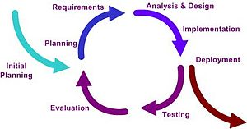](http://en.wikipedia.org/wiki/File:Iterative_development_model_V2.jpg)

**Figure 1 : Iterative and Incremental Development Model**

Iterative and incremental development is essential parts of the [Modified waterfall models](http://en.wikipedia.org/wiki/Modified_waterfall_models). It follows a similar process to the [plan-do-check-act](http://en.wikipedia.org/wiki/PDCA) cycle of [business process improvement](http://en.wikipedia.org/wiki/Business_process_improvement).

The basic idea behind this method is to develop a system through repeated cycles (iterative) and in smaller portions at a time (incremental), allowing [software developers](http://en.wikipedia.org/wiki/Software_developer) to take advantage of what was learned during development of earlier parts or versions of the system. Learning comes from both the development and use of the system, where possible key steps in the process start with a simple implementation of a subset of the software requirements and iteratively enhance the evolving versions until the full system is implemented. On each [iteration](http://en.wikipedia.org/wiki/Iteration), design modifications are made and new functional capabilities are added.

The iteration involves the redesign and implementation of iteration is to be simple, straightforward, and modular, supporting redesign at that stage or as a task added to the project control list. The level of design detail is not dictated by the iterative approach. In a light-weight iterative project the code may represent the major source of [documentation](http://en.wikipedia.org/wiki/Software_documentation) of the system; however, in a critical iterative project a formal [Software Design Document](http://en.wikipedia.org/wiki/Software_Design_Document) may be used. The analysis of iteration is based upon user feedback, and the program analysis facilities available. It involves analysis of the structure, modularity, [usability](http://en.wikipedia.org/wiki/Usability), reliability, efficiency, & achievement of goals. The project control list is modified in light of the analysis results.

**Passenger Clearance System for Customs**

The project that I have done is titled "Passenger Clearance System for Customs". This program is designed for the Customs Clearance purpose. Through this program the customs staffs will be able to keep records of each passengers carrying dutiable objects, and also be able to quickly serve those passengers. Through this system, customs staffs will be able to enter the information in the software about the passengers and according to the codes they chose revenue to be paid is automatically calculated by the system. The software also facilitates the print of computerized customs declaration. The users can view the reports, add information, edit information or delete information as per users' privilege defined by SUPER user or ADMIN user. The software contains reporting modules and reports could be easily generated. The software has Menus like: Menu, Customs Data, Tools and Help.

This program is based on Java, which is object oriented programming language. It uses all various features of JAVA. Besides, SQL is also used in this software. Specially, DML and DDL are used. Data Manipulation Language like Insert function, Update Function, Delete functions etc. Data Definition Language like Create, Alter, Drop, Trigger etc are used. Besides, this program is designed in NetBeans IDE Platform; it uses most of the components like Swing Components (JInternal Frame, JFrame, Menus, etc).

1. **Feasibility Study**

For the preparation of any kind of project, proper study of the implementation field is very necessary. Likewise, to prepare this software I have studied the condition, work behaviors of TIA Customs Office, Cargo Section, Kathmandu. Further, I am a staff of TIA Customs and working in the same office since 3 years. So, I am quite aware about the work load, problems and also the opportunities. As a customs staff, I have worked in that sector as a facilitator and have keenly observed the situation of passenger clearance section. I have also interacted with my colleagues and seniors about the possibility of implementing my software at Cargo Section. As per my personal experience, I have seen that the passenger clearance is a huge problem for customs which is also affecting image of customs in public. So, to protect the image of customs and also to speed up the work behavior of customs passenger clearance system computerized system is needed. Thus, I have planned to design this software.

1. **System Planning**

During the development of this project, I took some 6 weeks time in average. Starting from feasibility study, project planning, coding, testing, discussion with friends and seniors, improvement, reporting, report discussion and finalization steps are tentatively covered during this period. Such activities and time duration I spent is shown in Gantt chart.

**Table no. 1 : Gantt Chart**

|  |  |  |  |  |  |  |
| --- | --- | --- | --- | --- | --- | --- |
| **Activities/Duration** | **First Week** | **Second Week** | **Third Week** | **Fourth Week** | **Fifth Week** | **Sixth Week** |
| Feasibility Study |  |  |  |  |  |  |
| Planning |  |  |  |  |  |  |
| Coding and Testing |  |  |  |  |  |  |
| Project discussion with Supervisor, Teacher and Friends |  |  |  |  |  |  |
| Iteration (Revising and Improvement) |  |  |  |  |  |  |
| Reporting Part |  |  |  |  |  |  |
| Report Discussion |  |  |  |  |  |  |
| Project and Report Finalization |  |  |  |  |  |  |

1. **Methodology Adopted**

To develop this software, I have used Iterative and Incremental Development Model.

* 1. **Iterative and Incremental Development Model**

The iterative enhance model encounters the third limitation of the waterfall model and tries to combine a benefit of both prototyping and the waterfall model. The basic idea is that the software should be developed in increments, each increment adding some functional capability to the system unit the full system is implemented. At each step, extensions and design modifications can be made. Advantage of this approach is that it can result it better testing because testing each increment is likely to be easier than testing the entire system as in the waterfall model. The increment models provide feedback to the client i.e. useful for determining the final requirements of the system.

In the first step of the model, a simple initial implementation is done for a subset of the overall problem. This subset is one that contains some of the key aspects of the problem that are easy to understand and implement and which form a useful and usable system. A project control list is created that contains, in order, all the tasks that must be performed to obtain the final implementation. This project control list gives an idea of how far the project is at any given step from the final system.

Each step consists of removing the next task from the list, designing the implementation for the selected task, coding and testing the implementation, performing an analysis of the partial system obtained after this step, and updating the list as a result of the analysis. These three phases are called the designed phase, implementation phase and analysis phase. The process is integrated until the project control list is empty, at which time the final implementation of the system will be available.

The incremental model combines elements of the linear sequential model with the iterative of prototyping. Each linear sequence produces a deliverable "increment" of the software. When an incremental model is used, the first increment is a core product. That is, basic requirements are addressed, but many supplementary features remain undelivered. The customer uses the core product. As a result of use and /or evaluation, a plan is developed for the next increment. This process is repeated following the delivery of each increment, until the complete product is produced. The incremental process model is iterative in nature.

* 1. **Hardware and Software used**

For the development of this software various hardware and software are used. Hardware used in this software are :

1. A laptop / desktop computer with at least 40 GB HDD and 512 MB RAM)
2. Internet facilities
3. Printers

Similarly, software used in this software are :

1. Windows XP or higher OS f. JDK
2. JVM g. JRE
3. NetBeans IDE 8.0 h. Xampp Control
4. Apache i. MySQL
5. PHP
6. **Life Cycle of the project**

This project is an important part for the completion of MSC IT Second Semester and I have spent around six weeks in this project. This project cycles from the primary idea generation to final testing of the software. The life cycle of this project is resembled by the figure below:

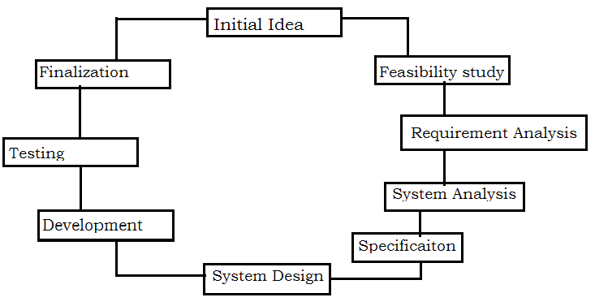

**Figure 2 : Life Cycle of the Project**

* 1. System Architecture Overview

This system is for Customs clearance purpose and in this system customs staff enter all required information about the passenger and the goods they have accompanied with them. The system then stores the information in the database and automatically calculates the revenue to be paid by the passenger. The authorized customs will also have the access to report handling and print the desired reports. The architecture can be presented in the figure below:

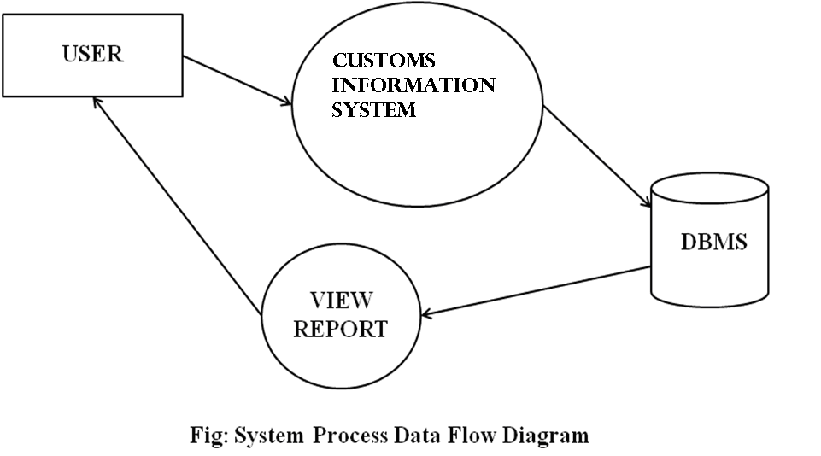**Figure 3: Data Flow Diagram**

* + 1. ER Diagram

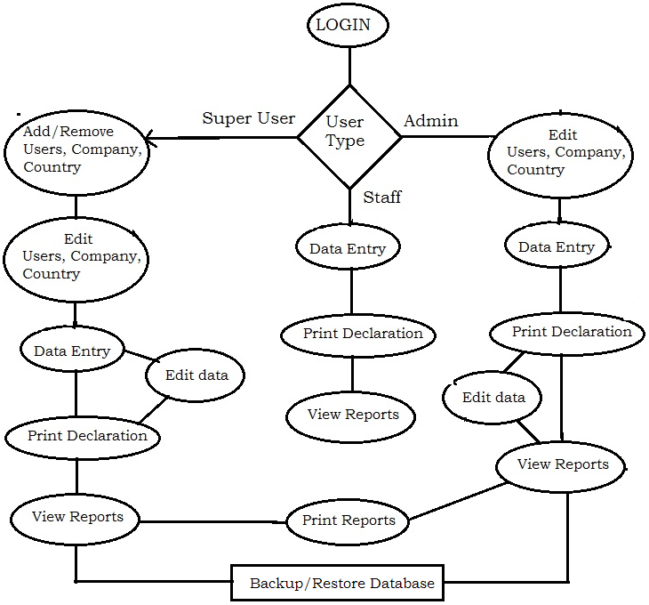

**Figure 4: ER Diagram of the project**

* + 1. Data Flow Chart (User chart)

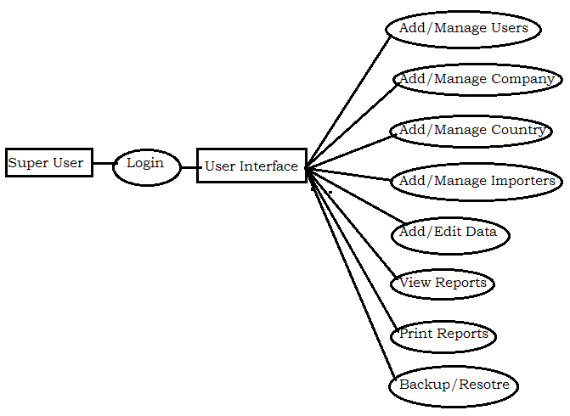

**Figure 5: Data Flow Chart of Super user**

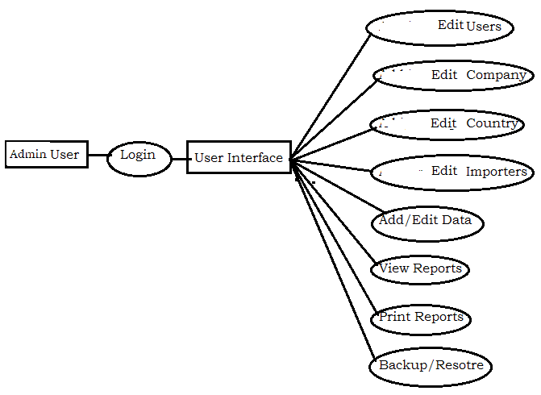

**Figure 6: Data Flow Chart of Admin user**

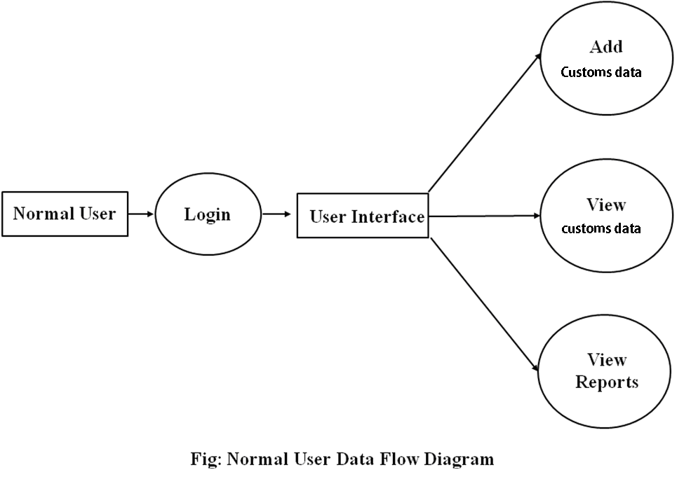

**Figure 7: Data Flow Chart of Normal User**

* + 1. System Flow Chart (Work Procedure)

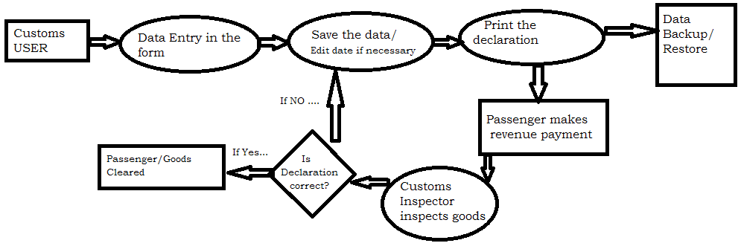

**Figure 8: Work Procedure/System Flow chart**

* 1. Testing Methods

In this project, as a developer I have used White box Testing Method. White box testing is the detailed investigation of internal logic and structure of the code. White box testing is also called glass testing or open box testing. In order to perform white box testing on an application, the tester needs to possess knowledge of the internal working of the code. The tester needs to have a look inside the source code and find out which unit/chunk of the code is behaving inappropriately.

While testing this application I have used Top-Down Testing strategy. Top-down testing tests the high levels of a system before testing its detailed components.

For system testing, Unit testing, Integration testing, validation testing and system testing are performed. That I have described in Testing cases section.

* + 1. Coding Tools

While developing this application, I have followed MySQL as my Back End Tool and NetBeans as Front End Tools.

* + - 1. Bank End Tools

Back end tools are such coding tools whose activities are not directly seen by the users. It happens inside for the successful execution of the program and has a huge importance although it is not directly shown. The logic, functions are coded in such tools. MySQL is used as Back end tools in this project.

* + - 1. Front End Tools

Front end tools are such coding tools whose activities or output are directly seen by the users. This tools is for user interface where user can interact with the program. It especially refers to the graphical representation of such logic, GUI. NetBeans IDE 8.0 is used as Front end tools in this project.

* + 1. Testing Cases

For system testing I have gone through four stages of testing: unit, integration, validation and system.

* 1. Unit Testing

Unit testing is actually testing if the coding are correct or not. To find out the correctness of codes, all units of program are tested, such as : Adding user, Adding company, Adding data, Updating information, help menus, backup and restore etc.

* 1. Integration Testing­

Integration Testing is the test of design. In this phase the integration of software is tested like Login, then data save, updated data, report forms etc are tested.

* 1. Validation Testing

Validation testing is the test if the software meets the requirement of customers or not. So, in this case the software activities, the accuracy of calculation, the usefulness of report modules are tested.

* 1. System Testing

System Testing is the test of whole system engineering. In this phase, the whole system is tested, data are entered, updated; reports are checked, verified and printed.

1. Data Dictionary

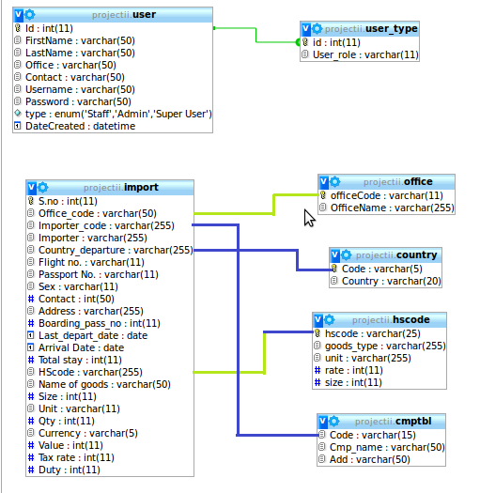

**Figure 10: Data Dictionary**

1. Detail of the project with snapshot and codes

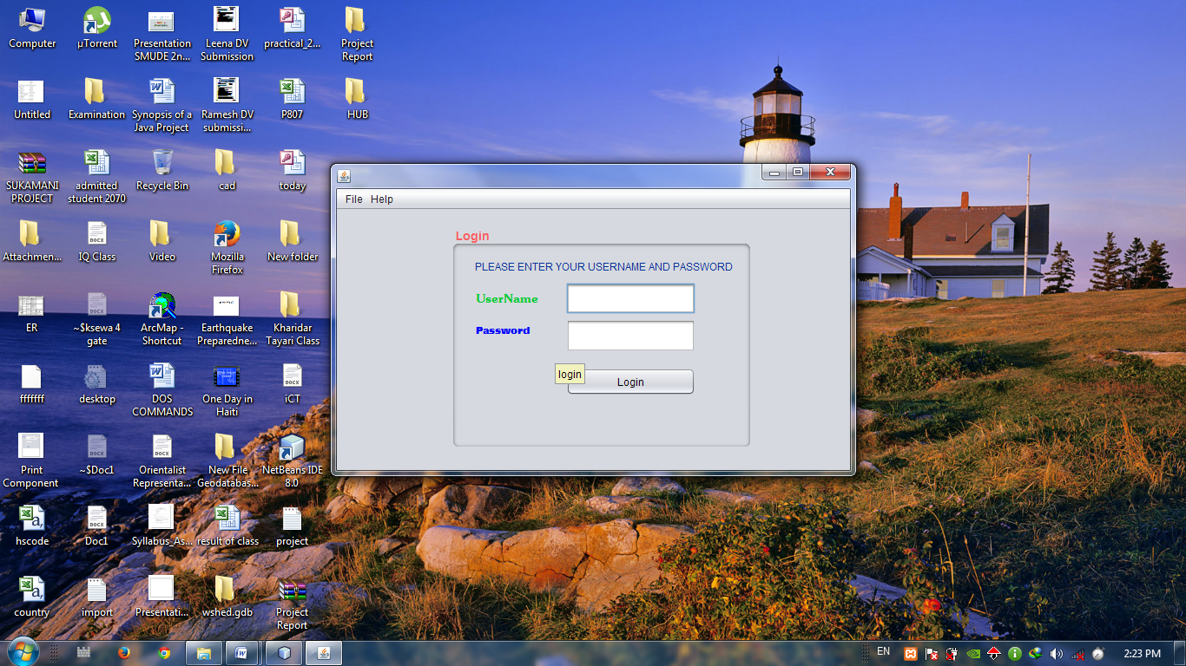

**Figure 10: Login Page**

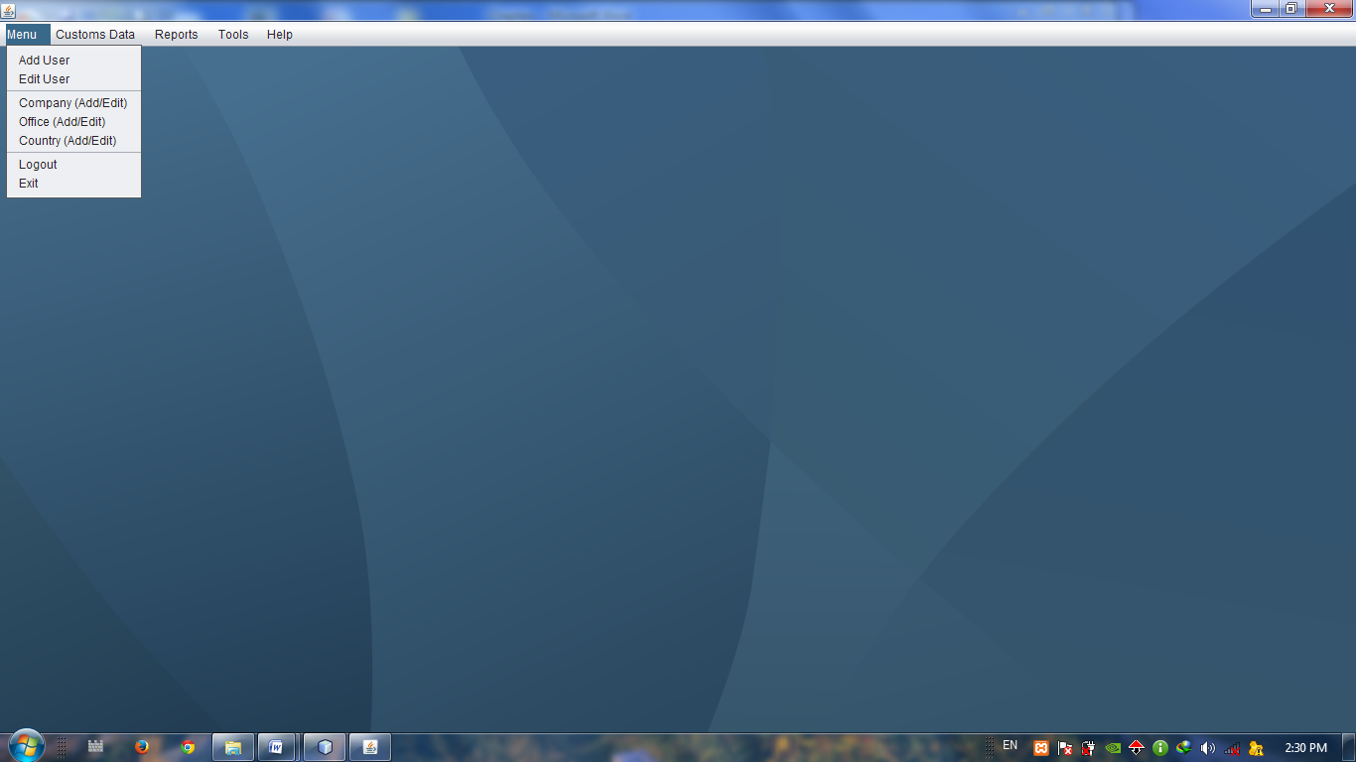

**Figure 11: Menu Page**

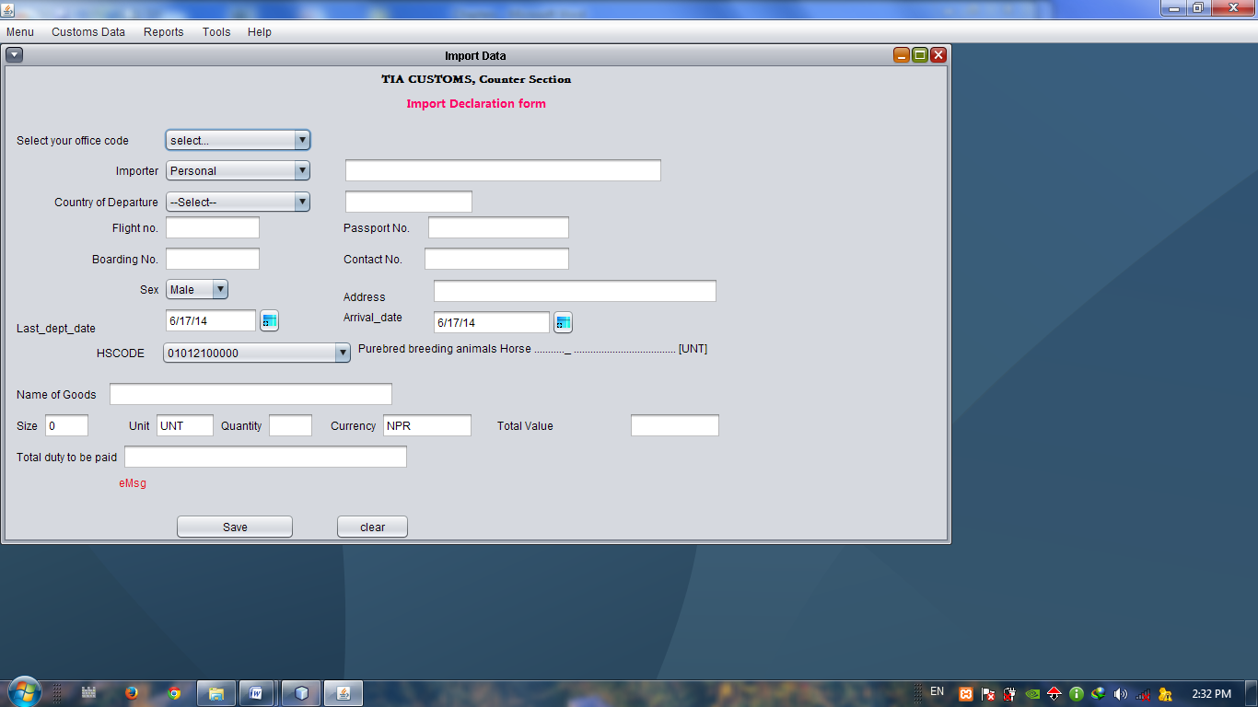

**Figure 12: Data Entry Page**

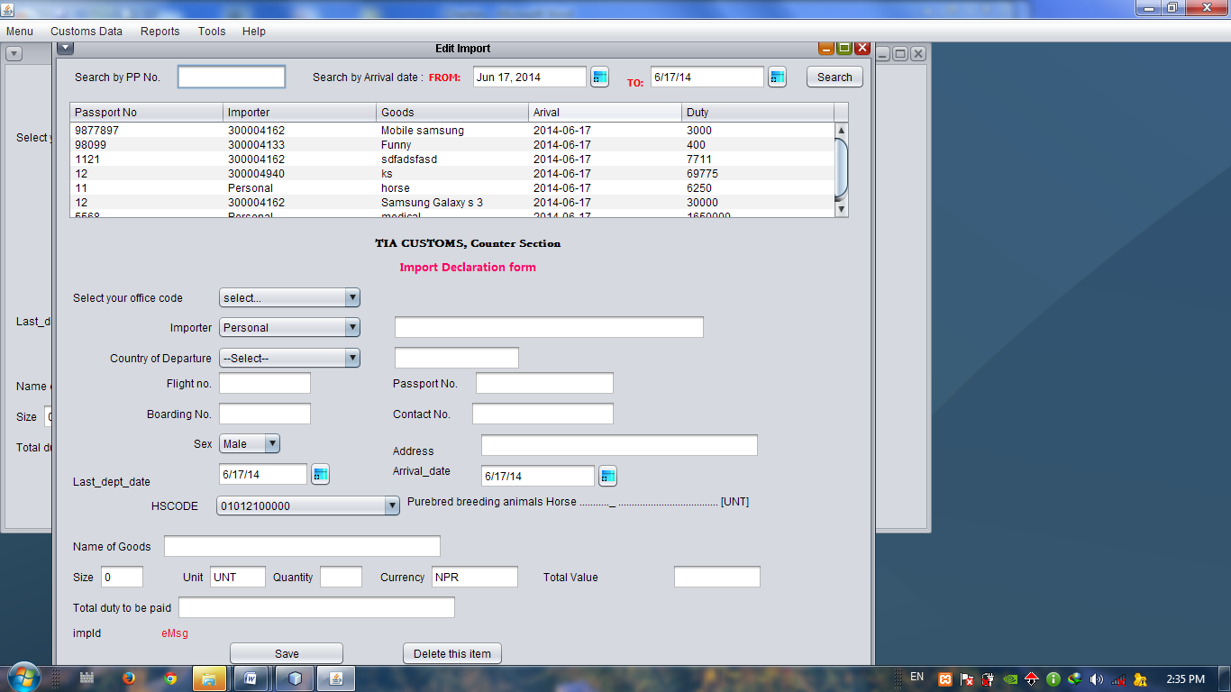

**Figure 13: Edit Data Page**

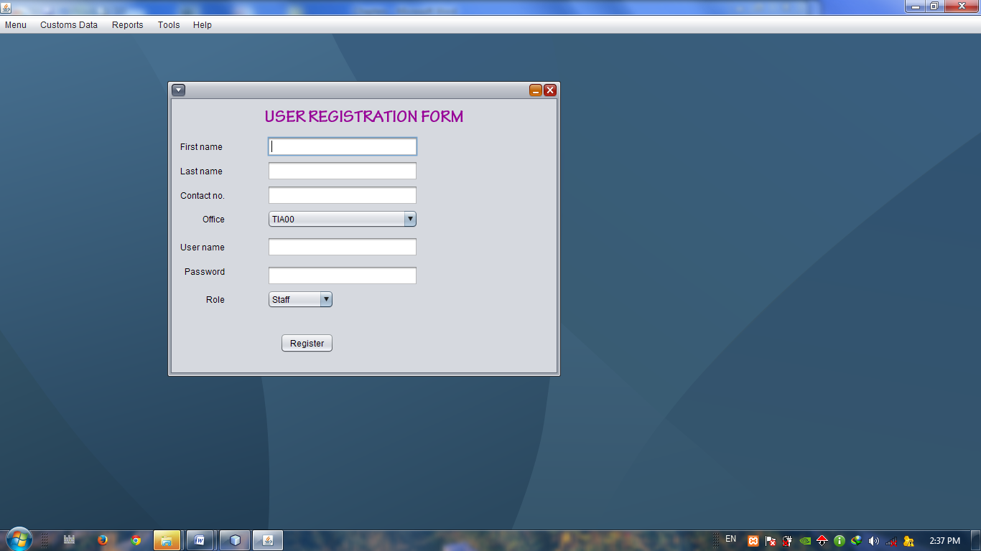

**Figure 14: User Registration Page**

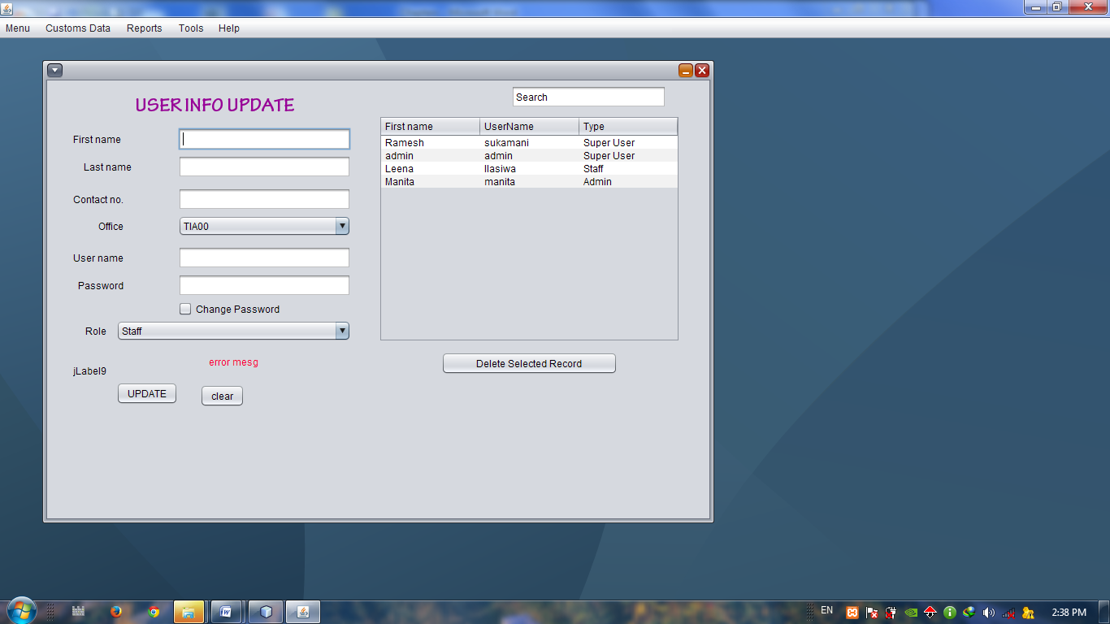

**Figure 15: User Info Update Page**

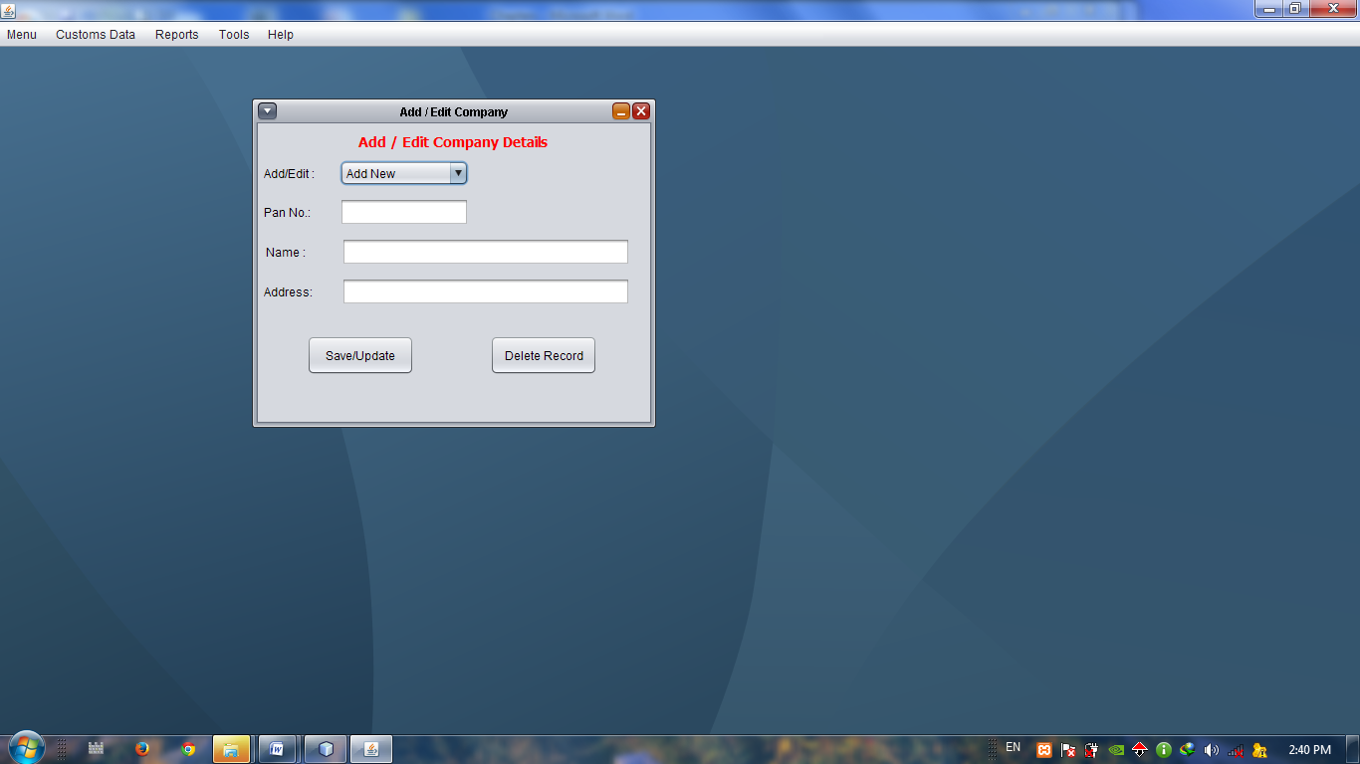

**Figure 16: Add/Edit Company Page**

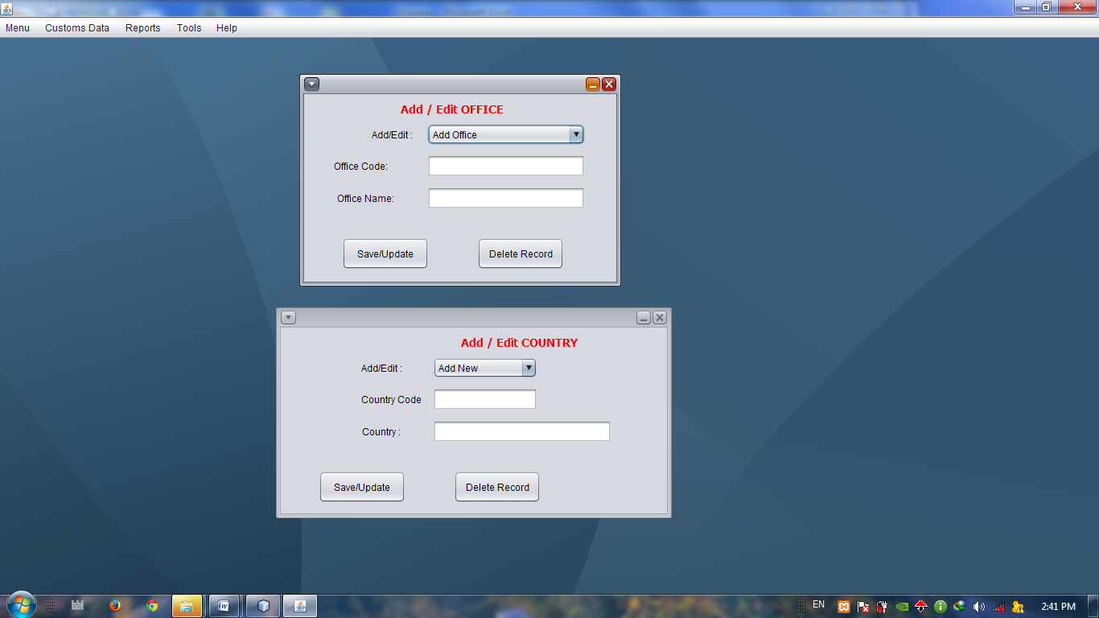

**Figure 17: Add/Edit Office Page**



**Figure 18: Add/Edit Country Page**

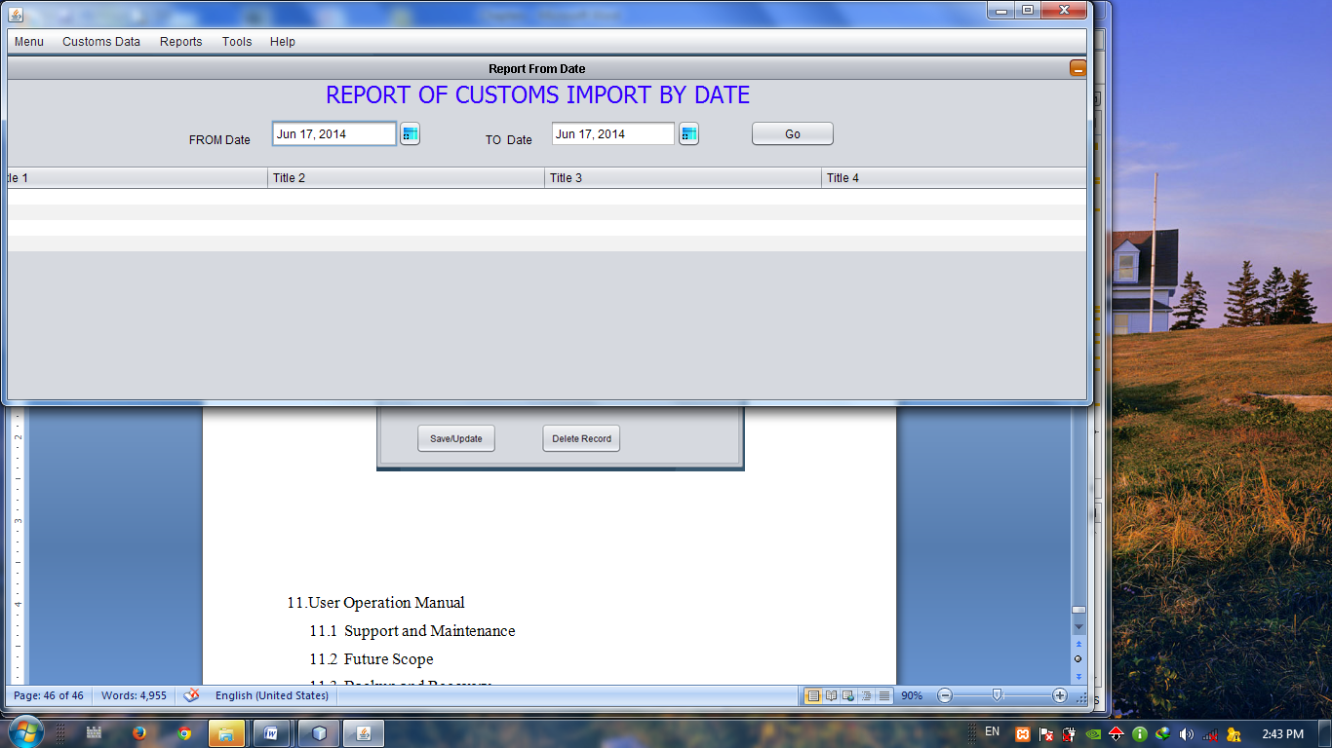

**Figure 19: Report by date Page**

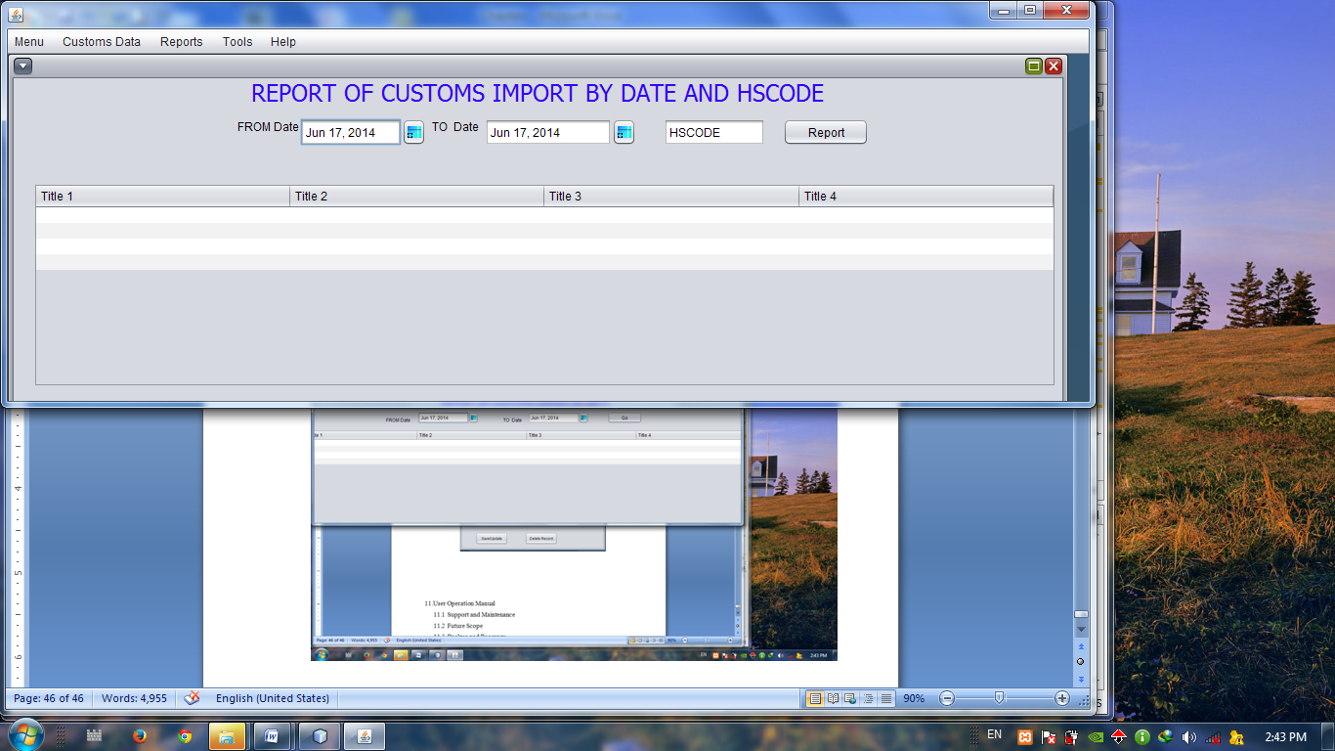

**Figure 20: Report by date and hscode Page**

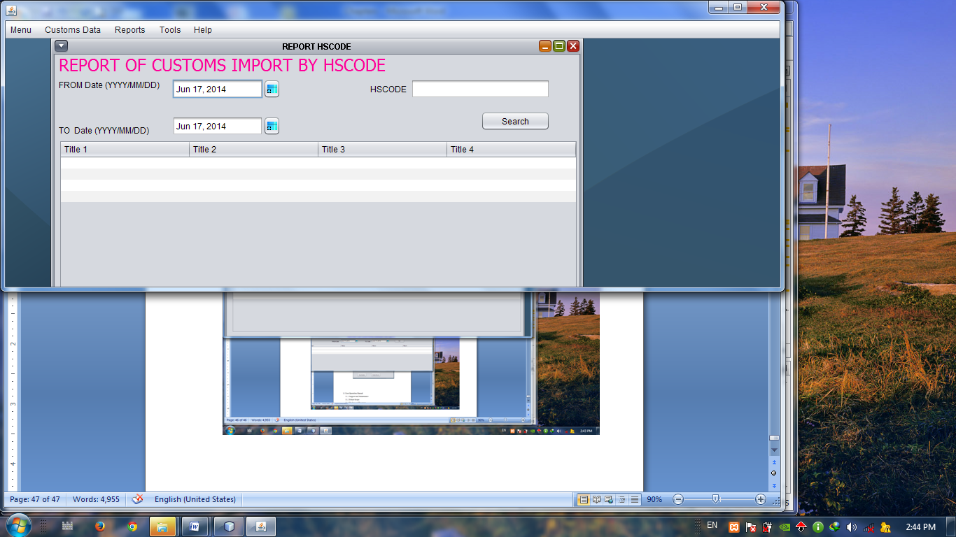

**Figure 21: Report by hscode Page**

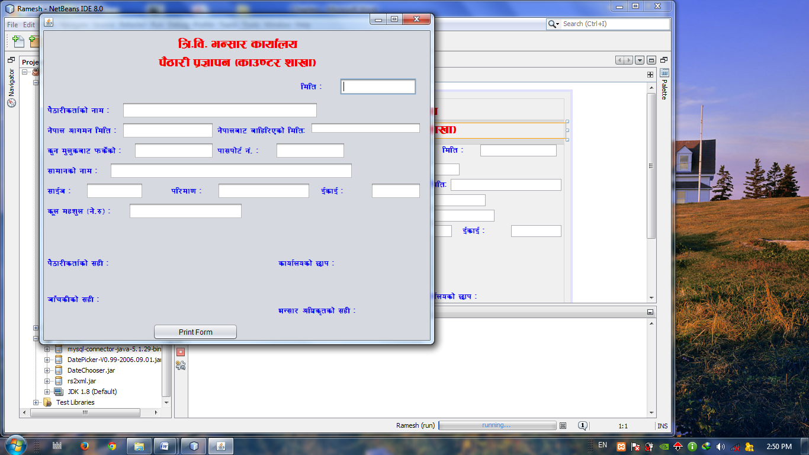

**Figure 22: Declaration Page**

1. User Operation Manual

This software is very user friendly and it is really very easy to operate. To use this software, one needs username and password that is provided by the Super User of this software. After Logging in the software, you can use this software as per your roles given.

* 1. Support and Maintenance

As this software is based on backend tool SQL and Front end tool NetBeans, the errors in the program is easily tracked and solved by anyone who have some general knowledge of JAVA and a bit SQL. And as a Java Programming, while updating errors, the whole program components are updated automatically. If any errors are found developers can be contacted soon. Phone : 9841358420 email: r_sukamani@yahoo.com

* 1. Future Scope

This software is designed for customs clearance purpose of passenger clearance section of Customs. And this software is to be used in TIA customs, Counter section. The passenger clearance system in almost all customs is similar, so this software can be launched in all the 30 customs offices of Nepal. Further, making some improvements the software can be used in other customs clearance. Use of this software will certainly make easier passenger clearance and quicker service which will certainly improve the image of CUSTOMS.

* 1. Backup and Recovery

The data posted in this software can be stored as a backup file in the computer. Backup must be regularly/daily done. Backup is a process of securing data in case of errors. In case, if the software fails to operate sometimes, it must be re-installed. But while doing so, all the data are lost. So, to secure such data and to restore such data into the software backup is needed. The backed up data can be easily restored.

* 1. Security

The platform of this software is java which is quite secure programming language. Further, this software maintains the facility of Backup and Restore, so as to protect data from loss. Besides, the software needs to be logged in to use. And only privileged users can user certain functions of the software. There is less chance of misuse of data and loss of data. In such case, this software is secured.

**Conclusion and Recommendation**

**Conclusion**

My project "Passenger Clearance System" is responsible for adding importers, country, and users in the software and for entering the information of the passenger and their goods to give them flexible frame work.

My project deals with the import part of customs where the passengers coming from abroad accompany some goods and that needs some revenue to be paid. This software automatically calculates the revenue by the reference of HSCODE which have rates for the customs.

Hence, although being a mini project, this project can give a clear view of customs, their procedure and also the revenue system of Nepal Customs. As this software is a desktop based application, it is easily accessible and very user friendly.

**Recommendation**

The materials presented in this report can be extended to access the applicability of an application. Based on the achieved results the following areas for further study are recommended.

This project can be very useful for customs clearance purpose at Passenger Clearance Section of Customs Offices of Nepal, which will not only bring accuracy in revenue calculation but also helps to serve the passengers quickly, smoothly. But still further research is needed to be done on various aspects of Customs and procedure.

A roadmap is to be drawn regarding the project that how to make the updated forms of data and others menus. The user privileges need to be defined as per the need of the customs offices.

Another important thing is that we must setup the rules and regulations regarding our project. And also address this automated system for the clearance purpose.

**Bibliography**

*Object Oriented Programming*. Ed. Fall 2011. (2013). Sikkim: Sikkim Manipal University, Directorate of Distance Education.

*Software Engineering*. Ed. Fall 2007. (2013). Sikkim: Sikkim Manipal University, Directorate of Distance Education.

*Java* *(programming language)*. In Wikipedia. Retrieved 15th June, 2014, from http://en.wikipedia.org/wiki/Java_(programming_language).

*NetBeans*. In Wikipedia. Retrieved 15th June, 2014. from http://en.wikipedia.org/wiki/NetBeans.

**Appendix**

The library files used in this application are presented in the appendices:

